Joe Hilleary
Tufts University
Classical Historians Fall 2022
Prof. Greg Crane
Exploring Scholar Descriptions in Tarikh al-Sudan
What did it take to become the qadi of the most illustrious scholarly communities in West Africa? That is the motivating question for this work. In reading Tarikh al-Sudan, one of the Timbuktu Chronicles that forms the basis for much of the written history of the Songhai Empire, I was struck by three chapters dedicated to describing the scholars of Djenné and Timbuktu. It’s well established that these two cities served as a crucial epicenter of Islamic learning and study for centuries. In chapters 6, 9, and 10 of Tarikh al-Sudan, the author, al-Sa’di, sketches out the network of men he feels represent the cream of West African scholars as of the time of his writing in the mid-1600s. If many of these figures just so happen to be his relatives, so be it. In any case, we are given a snapshot into what these communities looked like at a time when their reputation was spreading internationally.
During this period, leading cities throughout the Islamic world, including Djenné and Timbuktu, were led by qadis. A qadi, or judge, was appointed to dispense justice and apply religious law as the representative of the sovereign. So given the number of scholarly notables in these prestigious centers of learning, what were the markers of those elevated to this role? In his biographical chapters, al-Sa’di often appends long strings of epithets to his introductions of his subjects. This tendency led me to wander if there was a pattern to the descriptors applied to the scholars who became qadis.

Translation and Alignment
Before I embarked on my investigation, I began laying the groundwork for a digital edition of the biographical chapters. I partnered with Gio DiRusso, who was similarly interested in these sections of the text, and together we created English translations of the three biographical chapters and aligned those translations with the Arabic. We worked with a machine-readable version of the text made available by HathiTrust from an 1898 edition of Tarikh al-Sudan by Octave Houdas that included both the Arabic and a French translation. We manually corrected optical character recognition (OCR) errors in the Arabic and used DeepL to generate an English version from the French (unfortunately, at this time DeepL does not support direct translation from Arabic to English). We then aligned the automated English translation with each word of the Arabic.

Table Creation
Using the aligned version of the text, I mined descriptions to construct tables of the scholars referenced in each chapter. I only included scholars who had at least one descriptor assigned to them. That is, if a name appeared with no epithet, I did not include it. I also expanded from the strings of epithets to incorporate other methods of description, with the goal of capturing all of the major attributes al-Sa’di associated with the scholar in question. For example, almost all the scholars were described as faqih (jurisconsults), but in some instances, faqih wouldn’t appear in the string of epithets. Instead, after they were introduced, the scholar might be described as a master of fiqh (jurisprudence). In this case and similar ones, I would include fiqh, or the appropriate ism (noun), in the list of descriptors even though functionally it wasn’t serving as an direct descriptor in same way as the more clear cut cases of ism fa’ils (active participles), ism mafa’uls (passive participles), and sifas (adjectives).
I attempted to connect descriptors back to unique scholars from any place in which they were referenced, but in some cases it was not clear if two identical names referred to the same individual. In those cases, each ambiguous mention was given its own line in the table for that chapter followed by a number (e.g. Mahmoud (3)). If the same term was used to refer to the same scholar multiple times, I included it repeatedly in the list of descriptors for that scholar.
From these tables, I constructed a master table that included scholars from all three chapters. In addition to the scholars’ names and the lists of descriptors from the chapter tables, the master table also contains a unique ID number for each scholar, the chapter they are found in, and a list of the lemmas of all of their descriptors. In order to produce the lemmas, I leveraged the qalsadi python library. While imperfect, the lemmatization function provided a starting point for analysis of the descriptors. Another library, such as CAMeL Tools might perform better, but technological limitations prevented its use in this analysis. A different approach that might bear more fruit would be to go beyond the lemmatization of the descriptors to their basic roots. The example of faqih and fiqh above shows the value of this approach. Even properly lemmatized, these two descriptors would appear distinct, but ideally from an analysis perspective they should be the same, because they both just show the association of the scholar with fiqh. Using roots would link them since they both stem from f-q-h.
The final master table contains 179 scholars and 272 unique lemmas.

Graph Creation
Using the master table, I created a bipartite graph in which each scholar was linked to the lemmas of its descriptors. A simple visualization of this graph can be seen in figure 1. Red nodes represent scholars, indicated by their unique IDs, while blue nodes represent unique lemmas. The size of scholar nodes is constant, but the lemma nodes increase in size according to their degree (the number of scholars they describe).
Figure 1. Graph of Scholar Descriptions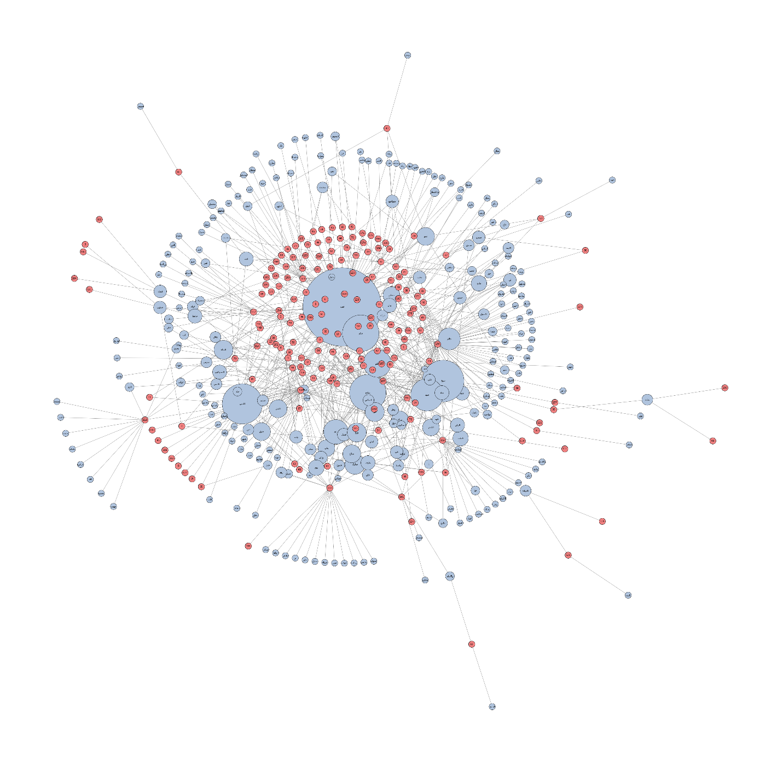
A passing glance at this graph tells us a few things. First, many descriptors only refer to a single scholar and are not repeated. At the same time, many scholars only have a single descriptor, most often faqih. In addition to faqih, other common descriptors include qadi, salih (pious), sheikh (master), seid (lord), wali (in this context saint), and ‘aalim (scholar).

Analysis of Qadi Descriptions
Once I had the graph object, I wanted to determine what descriptors were most commonly associated with qadis. I noticed from the visualization that the lemmatizer I used had distinguished between the singular and plural forms of qadi as well as between forms with a terminal yeh versus an aliph makusura. To compensate, I manually merged the nodes representing these alternate forms before conducting my analysis.
I then generated a list of the common neighbors between the node representing qadi and all of the other descriptor lemmas in the graph. The longer the list of common neighbors, the more qadis that were identified by a given descriptor. The results of my analysis showed that the most common terms applied to 41 individuals described as qadis were: faqih (21), ‘aalim (13), salih (12), jalil (6), and sheikh (4).
Of these top 5 descriptors, 4 are unsurprising, having simply been common descriptors overall. For instance, even though faqih is applied to more than half of the qadis, it’s applied to 67% of all scholars mentioned in these three chapters. As a result, despite being the most prevalent descriptor for this group, it in fact exhibits a lower rate for this descriptor than the general population of scholars. The exception to this is jalil. Translated variously as great, exalted, revered, honorable, or glorious, jalil only describes 8 scholars total across the three chapters. This means 75% of the scholars it describes are also qadis.
While I will leave it to those more versed in Arabic etymology to explore what the particular significance of jalil in this context might be, it seems to be the answer to the question “what does it take to be a qadi?”
Conclusion
The goal of this exercise is to demonstrate the kind of question that might be asked of the description graph presented here. In making this graph and its constituent data sources publicly available, I hope to encourage other domain experts to engage with the biographical chapters of Tarikh al-Sudan. Although al-Sa’di tends to be unfortunately light on dates and inconsistent or vague about familial ties, he does present robust descriptions of the Songhai Empire’s scholarly elite. From these descriptions, enterprising historians can glean a lot about how al-Sa’di viewed those he deemed worthy to write into the annals of history.

Hunwick, “Al-Saʿdī.”
Hunwick, “Timbuktu.”
Mauny, “Dienné.”
Tyan and Káldy-Nagy, “Ḳāḍī.”
ʻSadī and Houdas, Tarikh Es-Soudan.

